**Fone/Fax: (16) 3202-8077**

**Email:** [**vendas@wfsiderurgicos.com.br**](mailto:vendas@wfsiderurgicos.com.br)

**Home-page:** [**www.wfsiderurgicos.com.br**](http://www.wfsiderurgicos.com.br)

**Av. Major Hilário Tavares Pinheiro, 3500**

**Jaboticabal/SP**

PERFIL Z

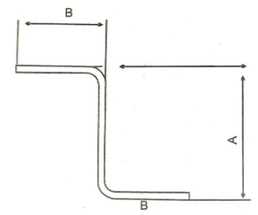

|  |  |  |  |  |
| --- | --- | --- | --- | --- |
| CHAPA | COMPRIMENTO | A | B | PESO / METRO |
| 16 | 3.000 | 30 | 15 | 0, 720 |
| 16 | 3.000 | 25 | 15 | 0, 660 |
| 16 | 3.000 | 22 | 15 | 0, 625 |

PERFIL U

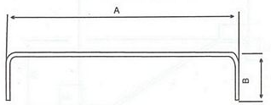

|  |  |  |  |  |
| --- | --- | --- | --- | --- |
| CHAPA | COMPRIMENTO | A | B | PESO / METRO |
| 16 | 3.000 | 160 | 15 | 2, 208 |
| 16 | 3.000 | 150 | 15 | 2, 088 |
| 16 | 3.000 | 140 | 15 | 1, 968 |
| 16 | 3.000 | 130 | 15 | 1, 848 |
| 16 | 3.000 | 60 | 15 | 1, 008 |
| 16 | 3.000 | 55 | 15 | 0, 948 |
| 16 | 3.000 | 30 | 15 | 0, 648 |
| 16 | 3.000 | 25 | 15 | 0, 588 |
| 16 | 3.000 | 20 | 15 | 0, 528 |
| 16 | 3.000 | 13 | 15 | 0, 444 |
| 16 | 3.000 | 25 | 10 | 0, 468 |
| 16 | 3.000 | 22 | 10 | 0, 432 |
| 16 | 3.000 | 20 | 10 | 0, 408 |
| 16 | 3.000 | 13 | 13 | 0, 395 |
| 16 | 3.000 | 10 | 13 | 0, 372 |

TUBO QUADRADO

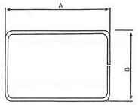

|  |  |  |  |  |
| --- | --- | --- | --- | --- |
| CHAPA | COMPRIMENTO | A | B | PESO / METRO |
| 16 | 3.000 | 80 | 80 | 3, 696 |
| 16 | 2.150 | 70 | 70 | 3, 216 |
| 16 | 3.000 | 60 | 60 | 2, 736 |
| 16 | 2.150 | 50 | 50 | 2, 256 |
| 16 | 3.000 | 40 | 40 | 1, 776 |

TUBO RETANGULAR

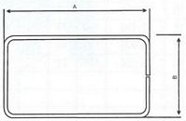

|  |  |  |  |  |
| --- | --- | --- | --- | --- |
| CHAPA | COMPRIMENTO | A | B | PESO / METRO |
| 16 | 3.000 | 90 | 30 | 2, 900 |
| 16 | 3.000 | 120 | 30 | 3, 620 |
| 16 | 3.000 | 150 | 30 | 4, 350 |
| 16 | 3.000 | 190 | 30 | 5, 300 |
| 14 | 3.000 | 150 | 30 | 5, 835 |
| 14 | 3.000 | 190 | 30 | 7, 200 |

CADEIRINHA COM EMENDA EXTERNA

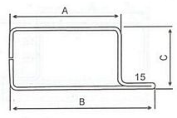

|  |  |  |  |  |  |
| --- | --- | --- | --- | --- | --- |
| CHAPA | COMPRIMENTO | A | B | C | PESO / METRO |
| 16 | 3.000 | 150 | 165 | 25 | 4, 416 |
| 16 | 3.000 | 75 | 90 | 25 | 2, 616 |
| 16 | 3.000 | 65 | 80 | 25 | 2, 376 |
| 16 | 3.000 | 50 | 65 | 30 | 2, 016 |
| 16 | 3.000 | 45 | 60 | 25 | 1, 896 |
| 16 | 3.000 | 40 | 55 | 25 | 7, 776 |
| 16 | 3.000 | 35 | 50 | 25 | 1, 656 |
| 16 | 3.000 | 30 | 45 | 25 | 1, 536 |
| 16 | 3.000 | 25 | 40 | 25 | 1, 416 |
| 16 | 3.000 | 20 | 35 | 25 | 1, 296 |
| 16 | 3.000 | 15 | 30 | 25 | 1, 236 |
| 16 | 3.000 | 20 | 35 | 20 | 1, 176 |

PERFIL TEE

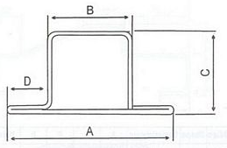

|  |  |  |  |  |  |  |
| --- | --- | --- | --- | --- | --- | --- |
| CHAPA | COMPRIMENTO | A | B | C | D | PESO / METRO |
| 16 | 3.000 | 80 | 50 | 30 | 15 | 2, 508 |
| 16 | 3.000 | 65 | 35 | 30 | 15 | 2, 148 |
| 16 | 3.000 | 60 | 30 | 30 | 15 | 2, 028 |
| 16 | 3.000 | 50 | 20 | 30 | 15 | 1, 788 |
| 16 | 3.000 | 45 | 15 | 30 | 15 | 1, 688 |
| 16 | 3.000 | 70 | 30 | 30 | 20 | 2, 268 |
| 16 | 3.000 | 60 | 30 | 25 | 15 | 1, 908 |
| 16 | 3.000 | 50 | 20 | 25 | 15 | 1, 668 |
| 16 | 3.000 | 45 | 15 | 25 | 15 | 1, 548 |

CADEIRINHA COM EMENDA INTERNA

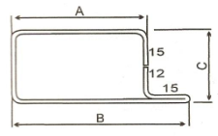

|  |  |  |  |  |  |
| --- | --- | --- | --- | --- | --- |
| CHAPA | COMPRIMENTO | A | B | C | PESO / METRO |
| 16 | 3.000 | 85 | 100 | 30 | 2, 976 |
| 16 | 3.000 | 75 | 90 | 30 | 2, 736 |
| 16 | 3.000 | 65 | 80 | 30 | 2, 496 |
| 16 | 3.000 | 50 | 65 | 30 | 2, 136 |
| 16 | 3.000 | 45 | 60 | 30 | 2, 016 |
| 16 | 3.000 | 40 | 55 | 30 | 1, 896 |
| 16 | 3.000 | 35 | 50 | 30 | 1, 776 |
| 16 | 3.000 | 30 | 45 | 30 | 1, 656 |
| 16 | 3.000 | 25 | 40 | 30 | 1, 536 |
| 16 | 3.000 | 20 | 35 | 30 | 1, 416 |

ENGATE COM 2 ABAS

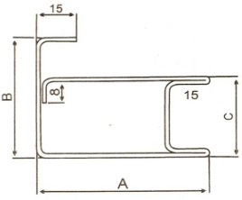

|  |  |  |  |  |  |
| --- | --- | --- | --- | --- | --- |
| CHAPA | COMPRIMENTO | A | B | C | PESO / METRO |
| 16 | 3.000 | 65 | 45 | 30 | 2, 916 |
| 16 | 3.000 | 50 | 45 | 30 | 2, 556 |
| 16 | 3.000 | 65 | 40 | 30 | 2, 856 |
| 16 | 3.000 | 50 | 40 | 30 | 2, 496 |

PERFIL ENGATE

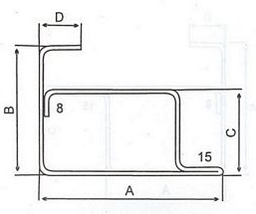

|  |  |  |  |  |  |  |
| --- | --- | --- | --- | --- | --- | --- |
| CHAPA | COMPRIMENTO | A | B | C | D | PESO / METRO |
| 16 | 3.000 | 65 | 45 | 30 | 48 | 2, 952 |
| 16 | 3.000 | 65 | 45 | 30 | 15 | 2, 556 |
| 16 | 3.000 | 50 | 45 | 30 | 33 | 2, 412 |
| 16 | 3.000 | 50 | 45 | 30 | 15 | 2, 196 |
| 16 | 3.000 | 45 | 45 | 30 | 28 | 2, 232 |
| 16 | 3.000 | 45 | 45 | 30 | 15 | 2, 076 |
| 16 | 3.000 | 50 | 40 | 25 | 33 | 2, 112 |
| 16 | 3.000 | 50 | 40 | 25 | 15 | 2, 076 |
| 16 | 3.000 | 45 | 40 | 25 | 28 | 2, 112 |
| 16 | 3.000 | 45 | 40 | 25 | 15 | 1, 956 |

CADEIRINHA COM 2 ABAS

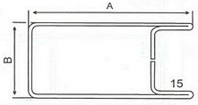

|  |  |  |  |  |
| --- | --- | --- | --- | --- |
| CHAPA | COMPRIMENTO | A | B | PESO / METRO |
| 16 | 3.000 | 100 | 30 | 3, 336 |
| 16 | 3.000 | 90 | 30 | 3, 096 |
| 16 | 3.000 | 80 | 30 | 2, 856 |
| 16 | 3.000 | 65 | 30 | 2, 496 |
| 16 | 3.000 | 60 | 30 | 2, 376 |
| 16 | 3.000 | 55 | 30 | 2, 256 |
| 16 | 3.000 | 50 | 30 | 2, 136 |
| 16 | 3.000 | 45 | 30 | 2, 016 |
| 16 | 3.000 | 40 | 30 | 1, 896 |
| 16 | 3.000 | 80 | 25 | 2, 736 |
| 16 | 3.000 | 65 | 25 | 2, 376 |
| 16 | 3.000 | 50 | 25 | 2, 016 |
| 16 | 3.000 | 45 | 25 | 1, 896 |
| 16 | 3.000 | 40 | 25 | 1, 776 |

TRILHO P/ PORTA DE CORRER

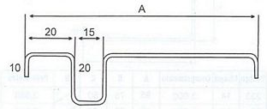

|  |  |  |  |
| --- | --- | --- | --- |
| CHAPA | COMPRIMENTO | A | PESO / METRO |
| 16 | 3.000 | 100 | 1, 776 |
| 16 | 2.000 | 100 | 1, 919 |
| 16 | 3.000 | 55 | 1, 236 |
| 16 | 2.000 | 55 | 1, 335 |

TRILHO P/ VITRO DE CORRER

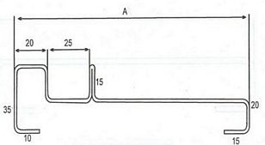

|  |  |  |  |
| --- | --- | --- | --- |
| CHAPA | COMPRIMENTO | A | PESO / METRO |
| 16 | 3.000 | 150 | 2, 604 |
| 16 | 2.000 | 150 | 2, 604 |
| 16 | 3.000 | 140 | 2, 484 |
| 16 | 2.000 | 140 | 2, 484 |

CAIXA PESO

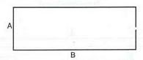

|  |  |  |  |  |
| --- | --- | --- | --- | --- |
| CHAPA | COMPRIMENTO | A | B | PESO / METRO |
| 16 | 1.000 | 170 | 170 | 8, 160 |
| 16 | 1.000 | 170 | 130 | 7, 206 |
| 16 | 1.000 | 170 | 120 | 6, 960 |
| 16 | 1.000 | 170 | 110 | 6, 720 |
| 16 | 1.000 | 170 | 100 | 6, 480 |
| 16 | 1.000 | 170 | 90 | 6, 240 |

CAIXA GRAU

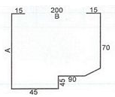

|  |  |  |  |  |
| --- | --- | --- | --- | --- |
| CHAPA | COMPRIMENTO | A | B | PESO / METRO |
| 16 | 3.000 | 200 | 200 | 7, 270 |
| 16 | 3.000 | 160 | 200 | 6, 223 |
| 16 | 3.000 | 140 | 200 | 6, 000 |
| 16 | 3.000 | 130 | 200 | 5, 900 |
| 16 | 3.000 | 120 | 200 | 5, 700 |

BATENTES

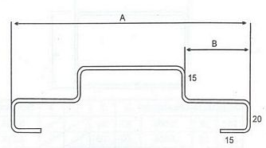

|  |  |  |  |  |
| --- | --- | --- | --- | --- |
| CHAPA | COMPRIMENTO | A | B | PESO / METRO |
| 16 | 3.000 | 150 | 33 | 2, 664 |
| 16 | 2.150 | 150 | 33 | 2, 664 |
| 16 | 3.000 | 140 | 33 | 2, 554 |
| 16 | 2.150 | 140 | 33 | 2, 554 |
| 16 | 3.000 | 130 | 33 | 2, 424 |
| 16 | 2.150 | 130 | 33 | 2, 424 |

CADEIRINHA ABERTA

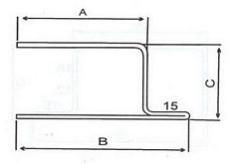

|  |  |  |  |  |  |
| --- | --- | --- | --- | --- | --- |
| CHAPA | COMPRIMENTO | A | B | C | PESO / METRO |
| 16 | 3.000 | 50 | 65 | 30 | 1, 848 |
| 16 | 3.000 | 45 | 60 | 30 | 1, 728 |
| 16 | 3.000 | 40 | 55 | 30 | 1, 608 |
| 16 | 3.000 | 35 | 50 | 30 | 1, 548 |
| 16 | 3.000 | 30 | 45 | 30 | 1, 368 |
| 16 | 3.000 | 15 | 30 | 30 | 1, 008 |

BATENTE CAMELINHO

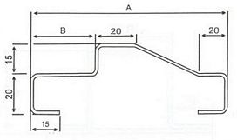

|  |  |  |  |  |
| --- | --- | --- | --- | --- |
| CHAPA | COMPRIMENTO | A | B | PESO / METRO |
| 16 | 3.000 | 160 | 38 | 2, 784 |
| 16 | 2.150 | 160 | 38 | 2, 784 |
| 16 | 3.000 | 150 | 38 | 2, 664 |
| 16 | 2.150 | 150 | 38 | 2, 664 |
| 16 | 3.000 | 140 | 38 | 2, 544 |
| 16 | 2.150 | 140 | 38 | 2, 544 |
| 16 | 3.000 | 130 | 38 | 2, 424 |
| 16 | 2.150 | 130 | 38 | 2, 424 |
| 16 | 3.000 | 160 | 33 | 2, 784 |
| 16 | 2.150 | 160 | 33 | 2, 784 |
| 16 | 3.000 | 150 | 33 | 2, 664 |
| 16 | 2.200 | 150 | 33 | 2, 700 |
| 16 | 3.000 | 140 | 33 | 2, 544 |
| 16 | 2.200 | 140 | 33 | 2, 600 |
| 16 | 3.000 | 130 | 33 | 2, 424 |
| 16 | 2.200 | 130 | 33 | 2, 500 |
| 16 | 3.000 | 120 | 33 | 2, 350 |
| 16 | 2.200 | 120 | 33 | 2, 350 |

REQUADRO LISO

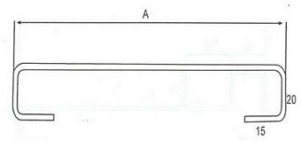

|  |  |  |  |
| --- | --- | --- | --- |
| CHAPA | COMPRIMENTO | A | PESO / METRO |
| 16 | 3.000 | 150 | 2, 376 |
| 16 | 3.000 | 140 | 2, 256 |
| 16 | 3.000 | 130 | 2, 136 |

GUIA PORTÃO DE CORRER

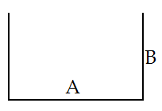

|  |  |  |  |  |
| --- | --- | --- | --- | --- |
| CHAPA | COMPRIMENTO | A | B | PESO / METRO |
| 16 | 3.000 | 35 | 40 | 1, 380 |
| 16 | 3.000 | 45 | 40 | 1, 500 |
| 16 | 3.000 | 55 | 40 | 1, 620 |
| 16 | 3.000 | 65 | 40 | 1, 750 |
| 14 | 3.000 | 65 | 40 | 2, 400 |

LAMINA VENEZIANA

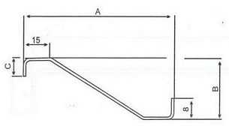

|  |  |  |  |  |  |
| --- | --- | --- | --- | --- | --- |
| CHAPA | COMPRIMENTO | A | B | C | PESO / METRO |
| 18 | 3.000 | 80 | 27 | 8 | 0, 911 |
| 18 | 3.000 | 80 | 27 | 24 | 0, 949 |
| 18 | 3.000 | 80 | 24 | 8 | 0, 808 |
| 18 | 3.000 | 80 | 24 | 20 | 0, 921 |
| 16 | 3.000 | 80 | 24 | 8 | 1, 020 |
| 18 | 3.000 | 80 | 19 | 8 | 0, 742 |
| 18 | 3.000 | 80 | 19 | 15 | 0, 799 |
| 18 | 3.000 | 50 | 50 | 8 | 0, 714 |

REQUADRO COM CADEIRINHA NO CENTRO

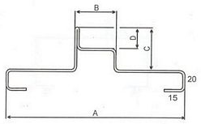

|  |  |  |  |  |  |  |
| --- | --- | --- | --- | --- | --- | --- |
| CHAPA | COMPRIMENTO | A | B | C | D | PESO / METRO |
| 16 | 3.000 | 150 | 30 | 30 | 15 | 3, 024 |
| 16 | 3.000 | 140 | 30 | 30 | 15 | 2, 904 |
| 16 | 3.000 | 150 | 25 | 30 | 15 | 2, 964 |
| 16 | 3.000 | 140 | 25 | 30 | 15 | 2, 844 |

GUIA VENEZIANA

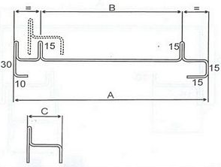

|  |  |  |  |  |  |
| --- | --- | --- | --- | --- | --- |
| CHAPA | COMPRIMENTO | A | B | C | PESO / METRO |
| 16 | 2.000 | 150 | 102 | 30 | 3, 324 |
| 16 | 2.000 | 140 | 102 | 30 | 3, 204 |
| 16 | 2.000 | 150 | 92 | 25 | 3, 324 |
| 16 | 2.000 | 140 | 92 | 25 | 3, 204 |
| 16 | 3.000 | 130 | 92 | 25 | 3, 084 |

TRILHO DE VENEZIANA

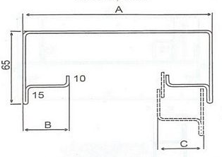

|  |  |  |  |  |  |
| --- | --- | --- | --- | --- | --- |
| CHAPA | COMPRIMENTO | A | B | C | PESO / METRO |
| 14 | 2.000 | 150 | 32 | 30 | 5, 920 |
| 14 | 2.000 | 140 | 27 | 30 | 5, 600 |
| 14 | 2.000 | 150 | 37 | 25 | 6, 080 |
| 14 | 2.000 | 140 | 32 | 25 | 5, 760 |
| 14 | 3.000 | 130 | 27 | 25 | 5, 440 |

TRILHO G

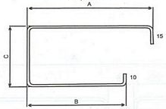

|  |  |  |  |  |  |
| --- | --- | --- | --- | --- | --- |
| CHAPA | COMPRIMENTO | A | B | C | PESO / METRO |
| 14 | 3.000 | 95 | 75 | 50 | 3, 680 |
| 14 | 2.000 | 95 | 75 | 50 | 3, 680 |
| 14 | 3.000 | 60 | 45 | 50 | 2, 720 |
| 14 | 2.000 | 60 | 45 | 50 | 2, 720 |
| 14 | 3.000 | 50 | 30 | 50 | 2, 240 |
| 14 | 2.000 | 50 | 30 | 50 | 2, 240 |
| 16 | 3.000 | 95 | 75 | 50 | 2, 900 |
| 16 | 2.000 | 95 | 75 | 50 | 2, 900 |
| 16 | 3.000 | 60 | 45 | 50 | 2, 250 |
| 16 | 2.000 | 60 | 45 | 50 | 2, 250 |
| 16 | 3.000 | 50 | 30 | 50 | 1, 830 |
| 16 | 2.000 | 50 | 30 | 50 | 1, 830 |

TAMPA TRILHO G

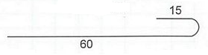

|  |  |  |
| --- | --- | --- |
| CHAPA | COMPRIMENTO | PESO / METRO |
| 16 | 3.000 | 1, 000 |
| 16 | 2.000 | 1, 000 |

BATENTE COM AMASSADO

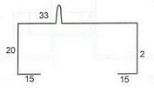

|  |  |  |  |  |
| --- | --- | --- | --- | --- |
| CHAPA | COMPRIMENTO | A | B | PESO / METRO |
| 16 | 3.000 | 150 | 33 | 3, 180 |
| 16 | 2.150 | 150 | 33 | 3, 180 |
| 16 | 3.000 | 140 | 33 | 3, 048 |
| 16 | 2.200 | 140 | 33 | 3, 200 |

TAMPA DA CAIXA LATERAL

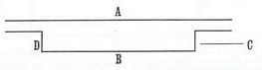

|  |  |  |  |  |  |  |
| --- | --- | --- | --- | --- | --- | --- |
| CHAPA | COMPRIMENTO | A | B | C | D | PESO / METRO |
| 16 | 2.500 | 200 | 170 | 15 | 15 | 2, 760 |
| 16 | 2.500 | 160 | 130 | 15 | 15 | 2, 300 |
| 16 | 2.500 | 140 | 110 | 15 | 15 | 2, 050 |
| 16 | 2.500 | 130 | 100 | 15 | 15 | 1, 920 |
| 16 | 2.500 | 120 | 90 | 15 | 15 | 1, 800 |

BATEDOR PORTÃO DE CORRER

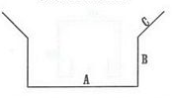

|  |  |  |  |  |  |
| --- | --- | --- | --- | --- | --- |
| CHAPA | COMPRIMENTO | A | B | C | PESO / METRO |
| 16 | 3.000 | 35 | 20 | 15 | 1, 260 |
| 16 | 3.000 | 45 | 30 | 15 | 1, 620 |
| 16 | 3.000 | 55 | 30 | 15 | 1, 740 |
| 16 | 3.000 | 65 | 30 | 15 | 1, 860 |

PORTÃO BASCULANTE

CAIXA LATERAL

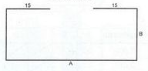

|  |  |  |  |  |
| --- | --- | --- | --- | --- |
| CHAPA | COMPRIMENTO | A | B | PESO / METRO |
| 16 | 2.500 / 3.000 | 200 | 200 | 7, 602 |
| 16 | 2.500 / 3.000 | 160 | 200 | 7, 200 |
| 16 | 2.500 / 3.000 | 140 | 200 | 6, 850 |
| 16 | 2.500 / 3.000 | 130 | 200 | 6, 730 |
| 16 | 2.500 / 3.000 | 120 | 200 | 6, 600 |
| 16 | 2.500 / 3.000 | 100 | 200 | 6, 380 |

TRILHO PORTÃO BASCULANTE

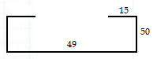

|  |  |  |
| --- | --- | --- |
| CHAPA | COMPRIMENTO | PESO / METRO |
| 14 | 2.500 / 3.000 | 2, 550 |

TAMPA CAIXA GRAU

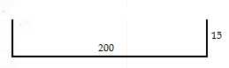

|  |  |  |
| --- | --- | --- |
| CHAPA | COMPRIMENTO | PESO / METRO |
| 16 | 2.500 / 3.000 | 2, 780 |

CAIXA PESO

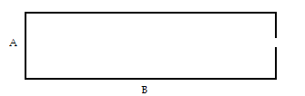

|  |  |  |  |  |
| --- | --- | --- | --- | --- |
| CHAPA | COMPRIMENTO | A | B | PESO / METRO |
| 16 | 1.000 | 170 | 170 | 8, 160 |
| 16 | 1.000 | 170 | 130 | 7, 200 |
| 16 | 1.000 | 170 | 120 | 6, 960 |
| 16 | 1.000 | 170 | 110 | 6, 720 |
| 16 | 1.000 | 170 | 100 | 6, 480 |
| 16 | 1.000 | 170 | 90 | 6, 240 |

CAIXA GRAU

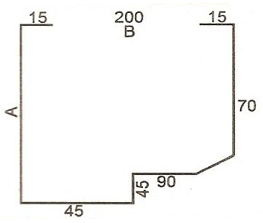

|  |  |  |  |  |
| --- | --- | --- | --- | --- |
| CHAPA | COMPRIMENTO | A | B | PESO / METRO |
| 16 | 3.000 | 200 | 200 | 7, 270 |
| 16 | 3.000 | 160 | 200 | 6, 223 |
| 16 | 3.000 | 140 | 200 | 6, 000 |
| 16 | 3.000 | 130 | 200 | 5, 900 |
| 16 | 3.000 | 120 | 200 | 5, 700 |

TRILHO STANLEY

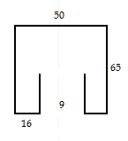

|  |  |  |
| --- | --- | --- |
| CHAPA | COMPRIMENTO | PESO / METRO |
| 16 | 3.000 | 2, 750 |
| 14 | 3.000 | 3, 700 |

CAPA VITRÔ MAX AR

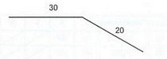

|  |  |  |
| --- | --- | --- |
| CHAPA | COMPRIMENTO | PESO / METRO |
| 16 | 3.000 | 0, 600 |

PERFIL Z - VITRAUX MAX AR

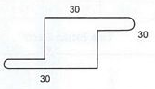

|  |  |  |
| --- | --- | --- |
| CHAPA | COMPRIMENTO | PESO / METRO |
| 16 | 3.000 | 1, 800 |

PERFIL PARA ESTRUTURA METÁLICA

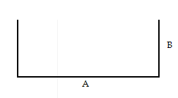

|  |  |  |  |  |
| --- | --- | --- | --- | --- |
| CHAPA | COMPRIMENTO | A | B | PESO / METRO |
| 14 | 6.000 / 3.000 | 75 | 40 | 2, 480 |
| 13 | 6.000 / 3.000 | 75 | 40 | 2, 790 |
| 14 | 6.000 / 3.000 | 70 | 30 | 2, 080 |
| 13 | 6.000 / 3.000 | 70 | 30 | 2, 340 |
| 14 | 6.000 / 3.000 | 100 | 40 | 2, 880 |
| 13 | 6.000 / 3.000 | 100 | 40 | 3, 240 |
| 14 | 6.000 / 3.000 | 92 | 30 | 2, 432 |
| 13 | 6.000 / 3.000 | 92 | 30 | 2, 736 |
| 12 | 6.000 / 3.000 | 125 | 40 | 4, 350 |
| 1/6” | 6.000 / 3.000 | 125 | 40 | 5, 022 |
| 12 | 6.000 / 3.000 | 117 | 30 | 3, 717 |
| 1/6” | 6.000 / 3.000 | 117 | 30 | 4, 336 |

PERFIL PARA ESTRUTURA METÁLICA

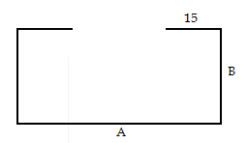

|  |  |  |  |  |
| --- | --- | --- | --- | --- |
| CHAPA | COMPRIMENTO | A | B | PESO / METRO |
| 14 | 6.000 / 3.000 | 75 | 40 | 2, 960 |
| 13 | 6.000 / 3.000 | 75 | 40 | 3, 300 |
| 14 | 6.000 / 3.000 | 100 | 40 | 3, 360 |
| 13 | 6.000 / 3.000 | 100 | 40 | 3, 780 |
| 13 | 6.000 / 3.000 | 125 | 40 | 4, 230 |
| 12 | 6.000 / 3.000 | 125 | 40 | 4, 935 |
| 1/8” | 6.000 / 3.000 | 125 | 40 | 5, 757 |

PERFIL PARA ESTRUTURA METÁLICA

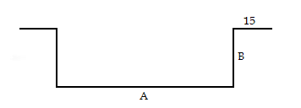

|  |  |  |  |  |
| --- | --- | --- | --- | --- |
| CHAPA | COMPRIMENTO | A | B | PESO / METRO |
| 14 | 6.000 / 3.000 | 75 | 40 | 2, 960 |
| 13 | 6.000 / 3.000 | 75 | 40 | 3, 330 |
| 14 | 6.000 / 3.000 | 100 | 40 | 3, 360 |
| 13 | 6.000 / 3.000 | 100 | 40 | 3, 780 |
| 13 | 6.000 / 3.000 | 125 | 40 | 4, 230 |
| 12 | 6.000 / 3.000 | 125 | 40 | 4, 935 |
| 1/8” | 6.000 / 3.000 | 125 | 40 | 5, 757 |

CHAPA PERFURADA

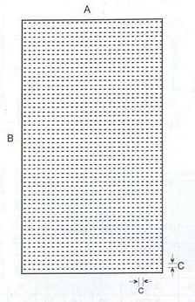

|  |  |  |  |  |
| --- | --- | --- | --- | --- |
| CHAPA | A | B | C | PESO / METRO |
| 18 | 500 | 2.000 | 30 | 1, 000 |
| 18 | 600 | 2.000 | 30 | 1, 200 |
| 18 | 700 | 2.000 | 30 | 1, 400 |
| 18 | 800 | 2.000 | 30 | 1, 600 |
| 18 | 900 | 2.000 | 30 | 1, 800 |
| 18 | 1000 | 2.000 | 30 | 2, 000 |

PAINEL REDONDO E COMPLEMENTOS

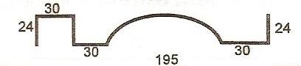

|  |  |  |
| --- | --- | --- |
| CHAPA | COMPRIMENTO | PESO / METRO |
| 18 | 2.000 / 2.200 2.500 / 3.000 | 3, 000 |

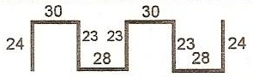

|  |  |  |
| --- | --- | --- |
| CHAPA | COMPRIMENTO | PESO / METRO |
| 18 | 2.000 / 2.200 2.500 / 3.000 | 2, 200 |

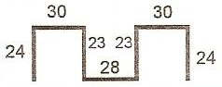

|  |  |  |
| --- | --- | --- |
| CHAPA | COMPRIMENTO | PESO / METRO |
| 18 | 2.000 / 2.200 2.500 / 3.000 | 1, 720 |

PAINEL REDONDO E COMPLEMENTOS

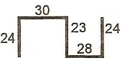

|  |  |  |
| --- | --- | --- |
| CHAPA | COMPRIMENTO | PESO / METRO |
| 18 | 2.000 / 2.200 2.500 / 3.000 | 1, 230 |

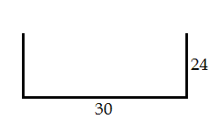

|  |  |  |
| --- | --- | --- |
| CHAPA | COMPRIMENTO | PESO / METRO |
| 18 | 2.000 / 2.200 2.500 / 3.000 | 0, 730 |

PAINEL RETANGULAR

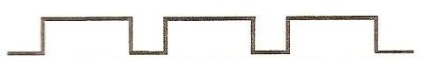

|  |  |
| --- | --- |
| CHAPA | COMPRIMENTO |
| 18 | 2.000 / 2.200 / 2.500 |

PAINEL VINCADO

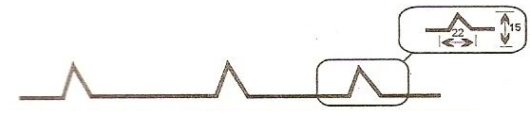

|  |  |
| --- | --- |
| CHAPA | COMPRIMENTO |
| 18 | 2.000 / 2.200 / 2.500 |

PERFIS P/ PORTAS DE ENROLAR

MONTANTE

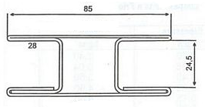

|  |  |  |
| --- | --- | --- |
| CHAPA | COMPRIMENTO | PESO / METRO |
| 16 | 3.000 | 4, 512 |

TRILHO

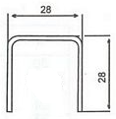

|  |  |  |
| --- | --- | --- |
| CHAPA | COMPRIMENTO | PESO / METRO |
| 16 | 3.000 | 0, 936 |

PERFIS P/ PORTAS DE ENROLAR

SOLERA

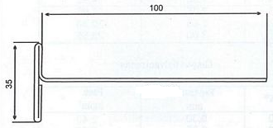

|  |  |  |
| --- | --- | --- |
| CHAPA | COMPRIMENTO | PESO / METRO |
| 16 | 3.000 | 2, 004 |

LÂMINA RAIADA

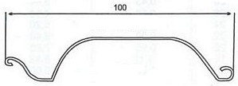

|  |  |  |
| --- | --- | --- |
| CHAPA | COMPRIMENTO | PESO / METRO |
| 24 | 6.000 | 0, 76 |

CHAPAS GALVANIZADAS

|  |  |  |
| --- | --- | --- |
| Nº | ESPESSURA mm | PESO Kg/m² |
| 10 | 3,40 | 27, 20 |
| 12 | 2,70 | 21, 60 |
| 13 | 2,30 | 18, 40 |
| 14 | 1,95 | 15, 60 |
| 16 | 1,55 | 12, 40 |
| 18 | 1,25 | 10, 00 |
| 19 | 1,11 | 8, 88 |
| 20 | 0,95 | 7, 60 |
| 22 | 0,80 | 6, 40 |
| 24 | 0,65 | 5, 20 |
| 26 | 0,50 | 4, 00 |
| 28 | 0,43 | 3, 44 |
| 29 | 0,35 | 2, 80 |
| 30 | 0,30 | 2, 40 |

CHAPAS FINAS A FRIO

|  |  |  |
| --- | --- | --- |
| Nº | ESPESSURA mm | PESO Kg/m² |
| 11 | 3,00 | 23, 55 |
| 12 | 2,65 | 20, 80 |
| 13 | 2,25 | 17, 66 |
| 14 | 1,90 | 14, 92 |
| 15 | 1,70 | 13, 60 |
| 16 | 1,50 | 12, 00 |
| 18 | 1,20 | 9, 60 |
| 19 | 1,06 | 8, 48 |
| 20 | 0,90 | 7, 20 |
| 21 | 0,85 | 6, 80 |
| 22 | 0,75 | 6, 00 |
| 24 | 0,60 | 4, 80 |
| 26 | 0,45 | 3, 60 |
| 28 | 0,38 | 3, 04 |
| 30 | 0,30 | 2, 40 |

CHAPAS FINAS A QUENTE (GROSSAS)

|  |  |  |
| --- | --- | --- |
| Nº | ESPESSURA mm | PESO Kg/m² |
| 18 | 1,20 | 9, 60 |
| 16 | 1,50 | 12, 00 |
| 14 | 2,00 | 16, 00 |
| 13 | 2,25 | 18, 00 |
| 12 | 2,65 | 21, 20 |
| 11 | 3,00 | 24, 00 |
| 10 | 3,35 | 26, 80 |
| 9 | 3,75 | 30, 00 |
| 8 | 4,25 | 34, 00 |
| 7 | 4,50 | 36, 00 |
| 3/16” | 4,75 | 38, 00 |
| 6 | 5,00 | 40, 00 |
| 1/4” | 6,30 | 49, 46 |
| 5/16” | 8,00 | 62, 80 |
| 3/8” | 9,50 | 74, 58 |
| 1/2" | 12,50 | 98, 13 |
| 5/8” | 16,00 | 125, 60 |
| 3/4" | 19,00 | 149, 15 |
| 7/8” | 22,00 | 175, 84 |
| 1 | 25,00 | 196, 25 |
| 1 1/4” | 31,50 | 247, 28 |
| 1 1/2" | 37,50 | 294, 38 |
| 2 | 50,00 | 392, 50 |
| 2 1/2" | 63,00 | 510, 25 |
| 3 | 75,00 | 588, 75 |
| 4 | 100,00 | 785, 00 |
| 4 1/2" | 110,00 | 836, 50 |
| 5 | 120,00 | 945, 00 |
| 5 1/4" | 130,00 | 1.020, 00 |
| 5 1/2" | 140,00 | 1.099, 00 |
| 6 | 150,00 | 1.177, 50 |

CHAPAS XADRES

|  |  |
| --- | --- |
| Nº | PESO Kg/m² |
| 11 | 3, 00 |
| 3/16” | 4, 75 |
| 1/4" | 6, 30 |

FERRO T

ABAS IGUAIS

|  |  |
| --- | --- |
| MEDIDAS | PESO Kg/m² |
| 3/4" x 3/4" x 1/8” | 0, 910 |
| 7/8” x 7/8” x 1/8” | 1.090 |
| 1” x 1” x 1/8” | 1.260 |
| 1 1/4" x 1 1/4" x 1/8” | 1.620 |
| 1 1/2" x 1 1/2" x 1/8” | 1.810 |
| 1” x 1” x 3/16” | 1.790 |
| 1 1/4" x 1 1/4" x 3/16” | 2.310 |
| 1 1/2" x 1 1/2" x 3/16” | 2.830 |
| 1 3/4” x 1 3/4” x 3/16” | 3.360 |
| 1 1/4" x 1 1/4" x 1/4” | 2.950 |
| 1 1/2" x 1 1/2" x 1/4” | 3.360 |
| 1 3/4" x 1 3/4" x 1/4” | 4.320 |
| 2” x 2” x 3/4” | 5.300 |

CANTONEIRAS

ABAS IGUAIS

|  |  |
| --- | --- |
| BITOLA | PESO / METRO LINEAR |
| 1/2” x 1/8” | 0, 570 |
| 5/8” x 1/8” | 0, 730 |
| 3/4" x 1/8” | 0, 920 |
| 7/8” x 1/8” | 1, 040 |
| 1” x 1/8” | 1, 270 |
| 1 1/4" x 1/8” | 1, 520 |
| 1 1/2" x 1/8” | 1, 830 |
| 1 3/4” x 1/8” | 2, 140 |
| 2” x 1/8” | 2, 460 |
| 1” x 3/16” | 1, 730 |
| 1 1/4" x 3/16” | 2, 190 |
| 1 1/2" x 3/16” | 2, 660 |
| 1 3/4” x 3/16” | 3, 150 |
| 2” x 3/16” | 3, 630 |
| 2 1/2" x 3/16” | 4, 570 |
| 1” x 1/4" | 2, 210 |
| 1 1/4" x 1/4" | 2, 860 |
| 1 1/2" x 1/4" | 3, 480 |
| 1 3/4” x 1/4" | 4, 120 |
| 2” x 1/4" | 4, 750 |
| 2 1/2" x 1/4" | 6, 100 |

|  |  |
| --- | --- |
| BITOLA | PESO / METRO LINEAR |
| 3” x 1/4" | 7, 290 |
| 4” x 1/4" | 9, 810 |
| 1/2" x 5/16” | 4, 260 |
| 2” x 5/16” | 5, 830 |
| 2 1/2" x 5/16” | 7, 410 |
| 3” x 5/16” | 8, 990 |
| 4” x 5/16” | 12, 200 |
| 1 1/2" x 3/8” | 4, 990 |
| 2” x 3/8” | 6, 990 |
| 2 1/2" x 3/8” | 8, 780 |
| 3” x 3/8” | 10, 690 |
| 3 1/2" x 3/8” | 12, 580 |
| 4” x 3/8” | 14, 410 |
| 2 1/4" x 1/2" | 10, 120 |
| 2 1/2" x 1/2" | 11, 460 |
| 2 3/4" x 1/2" | 12, 650 |
| 3” x 1/2" | 13, 930 |
| 3 1/2" x 1/2" | 16, 440 |
| 4” x 1/2" | 18, 970 |
| 4 1/2" x 1/2" | 21, 520 |
| 5” x 1/2" | 24, 300 |

FERRO E AÇO CHATO

( Peso / Metro Linear - Espessura )

|  |  |  |  |  |  |  |  |  |  |
| --- | --- | --- | --- | --- | --- | --- | --- | --- | --- |
| CHAPA | LARGURA / ESPESSURA | | | | | | | | |
| **3/8”** | **1/2”** | **5/8”** | **3/4”** | **7/8”** | **1”** | **1.1/4”** | **1.1/2”** | **1.3/4”** |
| **1/8”** | 0,23 | 0,31 | 0,39 | 0,47 | 0,55 | 0,63 | 0,79 | 0,94 | 1,10 |
| **1/2”** | - | - | - | 1,90 | 2,20 | 2,53 | 3,16 | 3,79 | 4,42 |

|  |  |  |  |  |  |  |  |  |  |
| --- | --- | --- | --- | --- | --- | --- | --- | --- | --- |
| CHAPA | LARGURA / ESPESSURA | | | | | | | | |
| **2”** | **2.1/4”** | **2.1/2”** | **2.3/4”** | **3”** | **3.1/4”** | **3.1/2”** | **4”** | **5”** |
| **1/8”** | 1,26 | 1,42 | 1,58 | 1,64 | 1,90 | 2,05 | 2,21 | 2,54 | 3,17 |
| **1/2”** | 5,06 | 5,70 | 6,32 | 6,96 | 7,59 | 8,22 | 8,85 | 10,10 | 12,65 |

PESO DE AÇO EM BARRAS

Kg / Metro

( Redondo e Quadrado )

|  |  |  |
| --- | --- | --- |
| Diâm. Pol. |  |  |
| 3/16 | 0,140 | - |
| 1/4 | 0,25 | 0,32 |
| 5/16 | 0,39 | 0,49 |
| 3/8 | 0,56 | 0,71 |
| 7/16 | 0,76 | 0,97 |
| 1/2 | 0,99 | 1,27 |

Peso Específico: 7,85

TUBOS DE AÇO COM COSTURA

|  |  |  |
| --- | --- | --- |
| Seção Quadrada | | |
| Bitola  mm | Espessura mm | Peso  Kg / M L |
| 15 x 15 | 0,90 | 0,450 |
| 1,20 | 0,555 |
| 20 x 20 | 0,90 | 0,56 |
| 1,20 | 0,74 |
| 1,50 | 0,93 |
| 2,00 | 1,130 |
| 25 x 25 | 1,20 | 0,94 |
| 1,50 | 1,18 |
| 30 x 30 | 1,20 | 1,13 |
| 1,50 | 1,40 |
| 2,00 | 1,770 |
| 40 x 40 | 1,20 | 1,51 |
| 1,50 | 1,88 |
| 2,00 | 2,50 |
| 50 x 50 | 1,20 | 1,88 |
| 1,50 | 2,35 |
| 2,00 | 3,12 |
| 3,00 | 4,340 |
| 60 x 60 | 1,20 | 2,25 |
| 1,50 | 2,85 |
| 1,90 | 3,76 |
| 80 X 80 | 1,50 | 3,83 |
| 100 X 100 | 1,50 | 4,700 |
| 2,00 | 6,400 |

TUBOS DE AÇO COM COSTURA

|  |  |  |
| --- | --- | --- |
| Seção Retangular | | |
| Bitola  mm | Espessura mm | Peso  Kg / M L |
| 30 x 20 | 1,20 | 0,94 |
| 1,50 | 1,100 |
| 2,00 | 1,440 |
| 40 x 20 | 1,20 | 1,13 |
| 1,50 | 1,40 |
| 40 x 30 | 1,20 | 1,32 |
| 1,50 | 1,64 |
| 2,00 | 2,240 |
| 50 x 20 | 1,20 | 1,32 |
| 1,50 | 1,64 |
| 50 x 30 | 1,20 | 1,51 |
| 1,50 | 1,88 |
| 2,00 | 2,400 |
| 0,90 | 1,140 |
| 60 x 40 | 1,20 | 1,900 |
| 1,50 | 2,300 |
| 2,00 | 3,040 |
| 70 x 30 | 1,50 | 2,29 |
| 2,00 | 3,040 |
| 1,20 | 1,900 |
| 80 x 40 | 1,50 | 2,85 |
| 1,20 | 2,300 |
| 2,00 | 3,780 |
| 90 x 30 | 1,50 | 2,67 |
| 100 x 50 | 1,50 | 3,500 |
| 2,00 | 4,650 |